Name: Date:

Template

# Teacher Note (Delete Before printing

Questions should be two pagers

* PDF: 1 & 2 to see double pages
* Print Version 2 & 3 to see double pages with a staple

Create PDF’s of the texts needed for completion

* Head First Java
* Barron’s Computer Science A
* Website by Kevin Workman
* Remember to look at the BlueJ and Greenfoot example programs for ideas, interpretations, and validity

Each Problem Should take about 1 class to introduce and have time to work on?

* Create a new unit plan for this once all problems are assembled

Create sample solutions for each problem

* Case Study
* Vocabulary for all questions after the document is written
* Finish learning objectives checklist
* Psuedo Code
* List of functions in the methods needed, parameters necessary

With a discussion of parameter boundaries

* Working program & file, if necessary
* Project Folder with internal and external documentation & commenting

Javadoc Tool Expectations

Levels of Sophistication for AP Level

* Creating the Program correctly
* Able to read vocabulary words
* Able to read and apply print resources
* Including needed comments in program so program is readable
* Able to complete more advanced questions (see Grading Appendix)
* Including more theoretical comments, preparing for AP Exam

In the AP Course 2nd semester,

* Review the more advanced comments or theoretical notes

Review Expectations

* Courier New Font for outputs (or whatever font seems good for the CMD Window)

# Textbook and Workbook

## HeadFirst Java

## Barron’s Computer Science

# Supporting Videos and Documents

## Videos

## Vocabulary

## Applied Skills

# Outline

# Questions

Question & Sections

Your Program Must

Add Comments For

Getting Ready for this Program

Getting Ready for this File

Specs for this Program

Example Combining Ideas

Case Study Space

Extra-Credit Reading

# Questions

**P1A.** Using “MyFirstApp.java” as a model, write a similar program, “MySecondApp.java”, that prints your “favorites”. Your program should do the following:

1. create and initialize an int with your favorite integer,
2. create and initialize a double with your favorite real number,
3. create and initialize a boolean with your favorite boolean value,
4. create and initailize a String with your favorite musical group.

Print each one of these on a separate line with identifying text.

**P1B.** In this program we will use Java’s mathematical operators to calculate the roots of a polynomial using the quadratic formula. Recall that if we have:



then the roots of the equation are given by:



Here the specs for your program:

1. Create three variables of type int and assign them numbers of your choosing (here’s a good set to start with: a = 1, b = -2, c = -15),
2. Calculate and print the value “” using System.out.println(). There is a built in function, Math.sqrt() that will return the square root of a number. For example, the statement Math.sqrt( 9 ) will return “3”.
3. Calculate and print the first root of the equation using the quadratic formula.
4. Calculate and print the second root of the equation using the quadratic formula.

When printing your roots, you may get the message: “NaN”, which is an acronym for “Not a Number”. This means that there is a mathematical calculation error of some sort in your program. In this program, this is most likely due to taking the square root of a negative number (i.e., negative discriminant b2-4ac).

1. Use an “if-else” statement to determine if the discriminant is negative BEFORE we take the square root of it. If the discriminant IS positive, the two real roots will be printed using System.out.println() statements as shown below:

The value of root 1 is = 5

The value of root 2 is = -3

1. If the discriminant is negative , then the following statement (or a clever facsimile of) should be printed:

“Sorry, your discriminant is negative. We cannot process imaginary root right now…”

The following values for a, b, and c will yield a negative discriminant:

a = 1

b = 1

c = 1

**P1C.** Let’s write a program that uses an if-else statement that will print whether a number is an even OR an odd number.

Here’s some sample output if the number is 15 (or any odd number):

15 is an odd number

And if the value is 8 (or any even number):

8 is an even number

Note: you can use the “modulus” or “remainder” operator (%) to determine the remainder of a division. For example, if the following lines of code is executed, the value of “remainder1” will be “1”, since 2 goes into 15 seven times with a remainder of 1. However, the value of “remainder2” will be “0” since 2 goes into 16 eight times with a remainder of “0”.

By definition, 0 % (any number ) = 0. For example, 0 % 3 = 0, 0 % 22 = 0, etc.

int remainder1 = 15 % 2; // remainder1 is 1

int remainder2 = 16 % 2; // remainder2 is 0

int remainder3 = 17 % 2; // remainder3 is 1

int remainder4 = 18 % 2; // remainder4 is 0

The modulus operator is helpful for finding remainders, but it is also the foundation for “public-key cryptography” which allows us to send information such as grade transcripts, online purchases, credit card payments, and bank statements securely through the Internet.

**P1D.** Let’s write a program that uses a for loop to print numbers 1 through 10 along with its square and a random number between the number and its square inclusive, each separated by a tab. In Java, you can create a tab by using the escape code “\t” as shown below:

System.out.println( number + “\t“ + numberSquared);

Here’s some sample output:

1 1 1

11 is a random number between 4 and 16 (inclusive)

2 4 2

3 9 5

4 16 11

5 25 22

49 is a random number between 7 and 49 (inclusive)

6 36 32

7 49 49

8 64 55

9 81 56

10 100 67

**P1E.** Now we’ll write a program to determine the number of digits in a given integer. Create an integer called “number” and place any number of your choosing in the variable. Your program should print the number of digits in the variable “number”. Hint: use a loop and integer division to in this algorithm.

**P1F.** Let’s write a program that creates an array of Strings of your top three favorite movies and an array of Strings of your top three favorite songs. Then use a for loop to print out your three favorite movies **on separate lines** AND a while loop to print out your three favorite songs all **on the same line**, separated by commas. Leave two blank lines between the movies and the songs. Below are some basics for creating, assigning values to, and printing array elements:

1. You can create an array that can hold three String objects with the following line of code:

String[] movies = new String[3];

2. You can assign values to individual elements of the array with the following line of code:

movies[0] = new String( “Star Wars: Episode 4” );

3. Finally, you can print all elements of an array using a for loop as shown below:

for( int index = 0; index < movies.length; index++ )

{

System.out.println( movies[index] );

} // end for loop

4. See LewTube for an example of how to use while loops

**P1G.** Write a program that creates an array that can hold 10 integer values. Then complete the following tasks:

a. Using a for loop and Math.random(), fill the array with random integer values between 0 and 100 inclusive.

b. Use a second for loop to print each of the numbers in the array with a single space between each number.

c. Use a third for loop to add up the numbers in array. Print the sum on a new line after the third for loop.

Note: When using a for loop with arrays, use the variable name “index” as the counter in the loop as shown below. This reinforces the fact that integer number that is changing represents the index of an array element.

for( int index = 0, index < myArray.length; index++ )

{

**// body of your for loop code goes here**

} // end for

d. Finally, write a fourth for loop to print the array in reverse order. Hint: you might have to change the initialization, test, and/or increment parts of the for loop.

**P1H.** Write a program that creates an array that can hold 10 integer values. Then fill and print the array according the following specifications:

a. Use a for loop and Math.random() to fill the array with random integer values between 0 and 100 THAT CAN BE EITHER POSITIVE OR NEGATIVE.

b. Use a separate while loop to print each of the numbers in the array on a separate line.

c. Use a second for loop to add the value of “10” to each element in the array. Be sure to actually change the values in the array as opposed to simply printing out the number in the array+10.

d. The program should then print out the number of positive integers in the array.

e. Use a third for loop to traverse the array and count the number of positive integers in the array.

**P1I.** Write a program that creates an array that can hold four Strings. Populate the array with four of your favorite musical artists. Below is a sample set of artists:

// feel free to use your own favorite artists

artists[0] = new String( “Mozart” );

artists[1] = new String( “Michael Jackson” );

artists[2] = new String( “Led Zeppelin );

artists[3] = new String( “Rush” );

a. Use a for loop to traverse the array to attempt find “Michael Jackson”. Print a statement for each corresponding element in the array stating whether or not you found Michael as shown below:

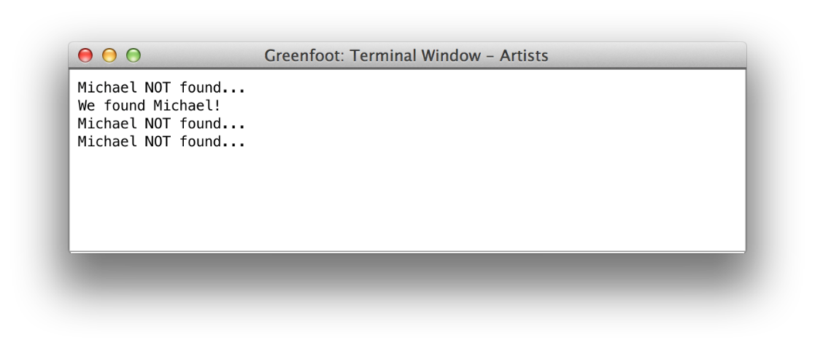

Check out the LewTube video on how to use the .equals() method of the String class to check for the “equality” of Strings.

Be sure to write your program so that if the number of elements in the array is changed, the traversal and “locating” code still works without having to make changes to your code, i.e., your code does not “break”. The phrase “breaking your code” or “broken code” is used when changes to your data (length of an array or contents of an array among other things) causes incorrect output by your program.

b. Now, leave one element in the array “empty” by place the value of “null” into the array element. For example, the following line of code will place the value of “null” into element 2.

artists[2] = null; // note that there are no quotes

// around null; it represents a value of

// “nothing” but can be checked using if

// statements

Now attempt to find “Michael Jackson” again. What type of “error” do you get? Using comments, write a brief explanation of what you think this “error” means. How could this “error” be avoided so that your program does not crash?

**P1J.** Write a program to simulate the login process for a website. Allow the user to input a String for the username and an int for a password using a JOptionPane as shown below. We will address more complex passwords later.

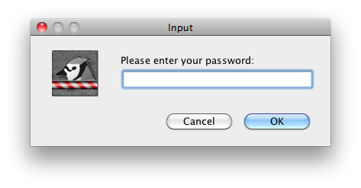

**(See LewTube for a tutorial on how to create and use “dialog boxes” as shown above)**

If the username AND password match the correct values, then print the following statement (or a reasonable facsimile of) using System.out.println():

“You have successfully logged in”

If the username/password combination does not match, print the following statement (or a reasonable facsimile of) using System.out.println():

“Login unsuccessful…try again”

**Learning Objective Checklist**

**(please print and complete after you have had all HW Set 1 programs checked off)**

**Place a check next to those items that you have mastered**

|  |  |
| --- | --- |
|  | Define and initialize a primitive of type int. |
|  | Define and initialize a primitive of type double. |
|  | Define and initialize a primitive of type boolean. |
|  | Define and initialize an object of type String. |
|  | Define and initialize an object of array of type int, double, boolean, or String. |
|  | Initialize and access array elements using [] notation. |
|  | Write if and if-else statements to analyze boolean statements. |
|  | Write a for loop to traverse and access array elements “forward” starting with index = 0 |
|  | Write a to traverse and access array elements “in reverse” starting with index = array.length-1 |
|  | Write a while loop to traverse and access array elements. |
|  | Use the relational operators >, <, >=, <=, = =, and != within the context of an if statement, for loop, and while loop. |
|  | Use the boolean operators && and || within the context of if statements and while loops. |
|  | Use a “counter” variable to count the number of elements in an array that meet a given criteria. |
|  | Use a “sum” variable to add any or all of the values in the array |
|  | Write comments using //. |
|  | Write the Java code to print output using “System.out.println()”. |
|  | Write code using Math.random() that returns a double precision number (double) from 0 inclusive to 1 exclusive. |
|  | Use the (int) cast to “cast” or convert a double precision number into an int |
|  | Write the Java code to create random numbers in any given range using Math.random(). |